

August 10, 2026

A regular meeting of the Lancaster County Water and Sewer District Board of Commissioners will be held at Lancaster County Water & Sewer District’s Administrative Business Office Conference Center, located at 1400 Pageland Highway, on Tuesday, August 11, 2026 at 6:30 p.m.

Agenda Items:

- Public Comment Period as Necessary

- Approval of Minutes

- Approval of ILWWTP Chemical Storage Improvements (State Utility) Change Order #1

- Approval of Local Funding Commitment for SC Rural Infrastructure Authority Basic Infrastructure Grant – Carmel Road

- Discussion of Drought and Consumption

- Executive Session to Receive Legal Advice on Pending Litigation, Contractual
Agreement and/or Personnel Issue (As Needed)

Upon returning to regular session, the Commission may take action as necessary
Note: The order of Agenda may change.

Your attendance will be greatly appreciated.

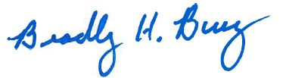
Bradley H. Bucy
District Manager

